Report on frequency analysis and visualization of Facial Action Coding System (FACS) – based expression using ARKit Blendshapes.

This report explains the behavioral frequency analysis pipeline developed for extracting and visualizing facial expression events from ARKit blendshape data. The system first processes participant CSV recordings, then synthesizes high-level facial expression using FACS guidelines to form action units which are then grouped together to detect significant behavioral peaks over time. The corresponding frames are extracted from the synchronized interview videos for visualization.
The goal of the pipeline is to automatically identify moments of strong emotion expression activity while reducing noise and false-positive detections through temporal smoothing.
Working:
1. Folder Structure
Each participant contains:
- A CSV file containing ARKit blendshape values over time
- A Participant folder structured as follows:
  - 01_name/
video.mov
take.json
video_metadata.json
The pipeline automatically matches participants by comparing the CSV participant ID (eg, P01) with the folder prefix. The Metadata extracted from the JSON files while the .mov file is used for frame extraction and visualization.
2. Expression Synthesis
Raw ARKit blendshapes are grouped into higher-level behavioral expression using Action Units (AU) based on the Facial Action Coding System (FACS) guidelines.
Table 1 below shows the groups and their corresponding blendshapes in this study:
Expression Group | Blendshape Components
Positive Social Expression | MouthSmileLeft, MouthSmileRight, CheekSquintLeft, CheekSquintRight
Concentration | BrowDownLeft, BrowDownRight, MouthFrownLeft, MouthFrownRight, MouthPressLeft, MouthPressRight, EyeSquintLeft, EyeSquintRight
Attentional Engagement | BrowInnerUp, BrowOuterUpLeft, BrowOuterUpRight
Skepticism | BrowOuterUpLeft, BrowOuterUpRight
Startle Response | EyeWideLeft, EyeWideRight, JawOpen
Tension / Stress | MouthDimpleLeft, MouthDimpleRight, MouthClose
Dejection | MouthFrownLeft, MouthFrownRight
Aversion | NoseSneerLeft, NoseSneerRight, EyeSquintLeft, EyeSquintRight, BrowDownLeft, BrowDownRight
Table 1. Expression Groups and corresponding ARKit Blendshapes
Each expression in computed using averaging or combined blendshape actiavtions. Table 2 shows all the equations used to compute these expression groups:
Expression Group | Equation
Positive Social Expression | [ ((MouthSmileLeft + MouthSmileRight) / 2 + (CheekSquintLeft + CheekSquintRight) / 2) / 2 ]
Concentration | [ ((BrowDownLeft + BrowDownRight) / 2 + (MouthFrownLeft + MouthFrownRight) / 2 + (MouthPressLeft + MouthPressRight) / 2 + (EyeSquintLeft + EyeSquintRight) / 2) / 4 ]
Attentional Engagement | [ (BrowInnerUp + BrowOuterUpLeft + BrowOuterUpRight) / 3 ]
Skepticism | [ | BrowOuterUpLeft - BrowOuterUpRight | ]
Startle Response | [ (EyeWideLeft + EyeWideRight + JawOpen) / 3 ]
Tension / Stress | [ (MouthDimpleLeft + MouthDimpleRight + MouthClose) / 3 ]
Dejection | [ (MouthFrownLeft + MouthFrownRight) / 2 ]
Aversion | [ ((NoseSneerLeft + NoseSneerRight) / 2 + (EyeSquintLeft + EyeSquintRight) / 2 + (BrowDownLeft + BrowDownRight) / 2) / 3 ]
Table 2. Expression groups and their corresponding equations
3. Frequency and Peak Detection
For each synthesized expression, the mean (μ)and standard deviation (σ) are calculated from the first 25 seconds of the interview to derive an equation for an activation threshold where:
Threshold=μ+2.5σ
This dynamic computation is employed so that the expression threshold is always relative to the interviewee’s neutral, base expression. The peaks are detected using SciPy’s find_peaks() function. To visualize these base expressions, a screening module was devised to extract the participant’s most expressionless resting state in the first 25 seconds. Physical movement artifacts are filtered by negating frames corrupted by movements like speech and blinking. A composite neutrality score (N_{s}) is then calculated by summing the concurrent intensities of the core smoothed expression signals, mentioned above, in the valid frames. A one second temporal distance constraint is enforced to avoid extracting sequential frames from a single moment. As a result, we are able to isolate top 5 distinct, high-fidelity neutral candidate frames for baseline visualization which figure 1 below shows:

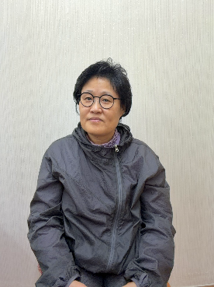

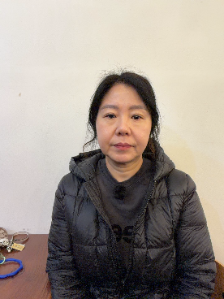

Figure 1. Sample neutral faces of four candidates
To reduce noise and micro-fluctuations, the signal is smoothed using a Satvizky-Golay filter before a second peak detection pass is performed. This allows us to have a smoothed graph for our behavioral tracking and also filter false positive, that allow for better statistical analysis. One example of a filtered report is shown below in Table 3 for participant 1:
Expression Group | Raw_Mean_Baseline | Raw_Max_Observed | Raw_Bout_Count_Events | Smoothed_Bout_Count_Events | False_Positives_Filtered_Out
Positive Engagement/Smile | 0.024303 | 0.797432 | 44 | 30 | 14
Concentration/Negative Emotion | 0.065569 | 0.35417 | 66 | 41 | 25
Surprise | 0.234236 | 0.798354 | 97 | 53 | 44
Skepticism | 0.000652 | 0.060722 | 81 | 38 | 43
Shock | 0.180143 | 0.609515 | 122 | 87 | 35
Tension/Stress | 0.040349 | 0.3367 | 68 | 32 | 36
Sadness/Dejection | 0.103085 | 0.45283 | 81 | 51 | 30
Critical Evaluation | 0.173242 | 0.350571 | 96 | 50 | 46
Table 3. Quantitative Comparison of Raw and Filtered Facial Expression Peak-Bout Events.

4. Visualization and recording of expression intensities
For each expression, our pipeline generates: a. Raw Intensity time plots b. Smoothed trend Plots and c. Combined Behavioral profile plots across all the expressions shown by the figures below on which the behavioral peaks are marked along with the activation threshold.

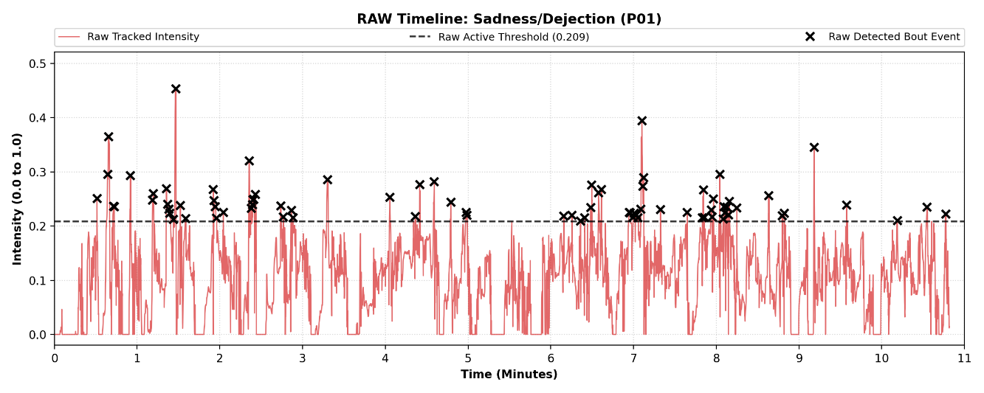

Figure 1. Raw Plot for Sadness/Dejection Impression

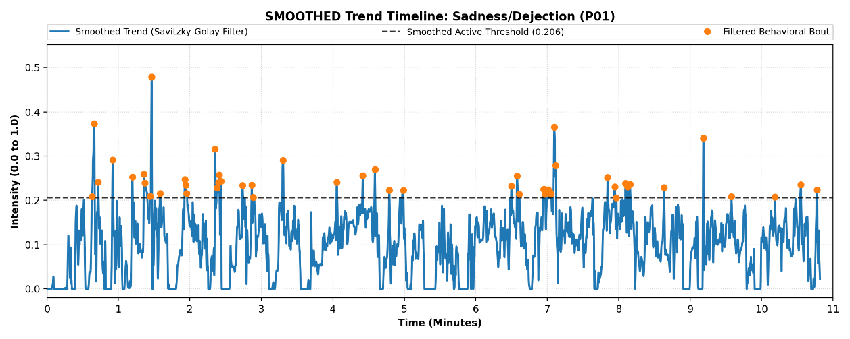

Figure 2. Filtered/Smoothed Plot for Sadness/Dejection Impression

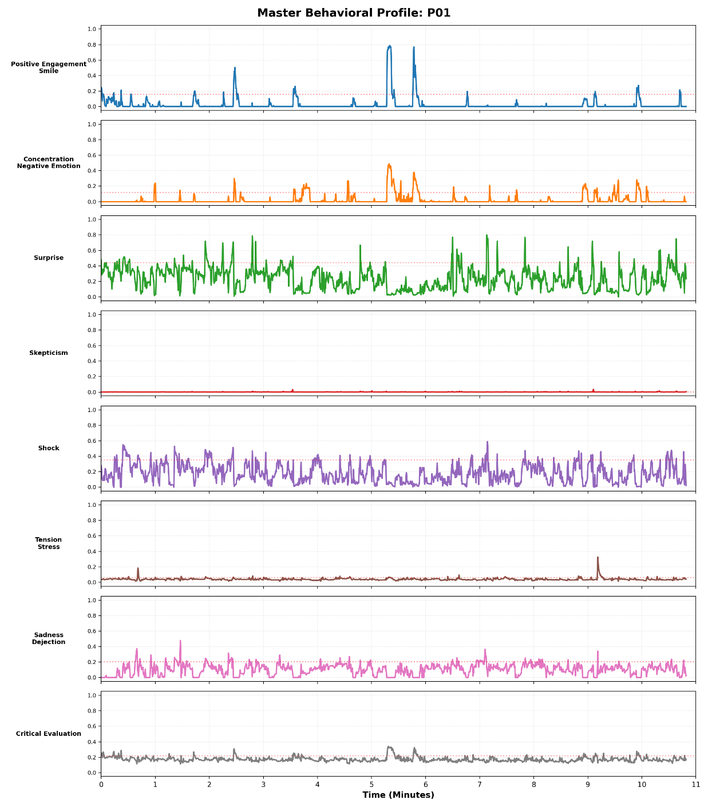

Figure 3. Filtered/Smoothed Plot for Sadness/Dejection Impression
The expression intensity peak information is reported in an csv file where each peak is recorded with a unique ID, its peak intensity, the corresponding expression group, timestamp, frame index, and finally the individual blendshapes constituting that action unit. A condensed format showing an isolated entry from each expression can be seen in table 4:

Event ID | Expression | Timestamp | Frame Index | Peak Intensity | Threshold | Contributors
Positive_Social_Expression_001 | Positive Social Expression | 01:42.6 | 6156 | 0.31060 | 0.264964 | CheekSquintRight (0.481), CheekSquintLeft (0.426), MouthSmileLeft (0.178), MouthSmileRight (0.169)
Concentration_004 | Concentration | 00:39.5 | 2373 | 0.29323 | 0.151902 | MouthPressLeft (0.483), MouthPressRight (0.464), MouthFrownRight (0.370), MouthFrownLeft (0.352), EyeSquintRight (0.324), EyeSquintLeft (0.324), BrowDownLeft (0.034), BrowDownRight (0.034)
Attentional_Engagement_010 | Attentional Engagement | 07:07.9 | 25676 | 0.79921 | 0.544128 | BrowInnerUp (0.870), BrowOuterUpRight (0.709), BrowOuterUpLeft (0.706)
Skepticism_011 | Skepticism | 03:03.0 | 10980 | 0.00187 | 0.001545 | BrowOuterUpRight (0.453), BrowOuterUpLeft (0.451)
Startle_Response_003 | Startle Response | 01:21.4 | 4884 | 0.5290 | 0.483516 | EyeWideRight (0.675), EyeWideLeft (0.675), JawOpen (0.129)
Tension_Stress_042 | Tension/Stress | 10:06.3 | 36379 | 0.07342 | 0.055677 | MouthClose (0.188), MouthDimpleRight (0.019), MouthDimpleLeft (0.017)
Dejection_021 | Dejection | 02:02.4 | 7345 | 0.19620 | 0.122669 | MouthFrownLeft (0.182), MouthFrownRight (0.178)
Aversion_013 | Aversion | 03:51.0 | 13862 | 0.30331 | 0.229169 | EyeSquintLeft (0.545), EyeSquintRight (0.525), NoseSneerRight (0.191), NoseSneerLeft (0.170), BrowDownRight (0.165), BrowDownLeft (0.164)

Table 4. Condensed CSV Output Showing Unique Event IDs and Structuring Attributes Across All Expression Groups.

5. Frame synchronization with expression events & heatmap
For every detected event (peak), synchronized video evidence frames are extracted for optimal visualization. 3 frames are used: 0.5s before the peak, the peak activation frame, & 0.5s after the peak activation. The generated panel includes information about the participant, expression type, timestamp, intensity, and dominant contributors, all of which are reflected in the corresponding csv file. This allows for rapid visual inspection of our detected behavioral moments. An example is shown below:

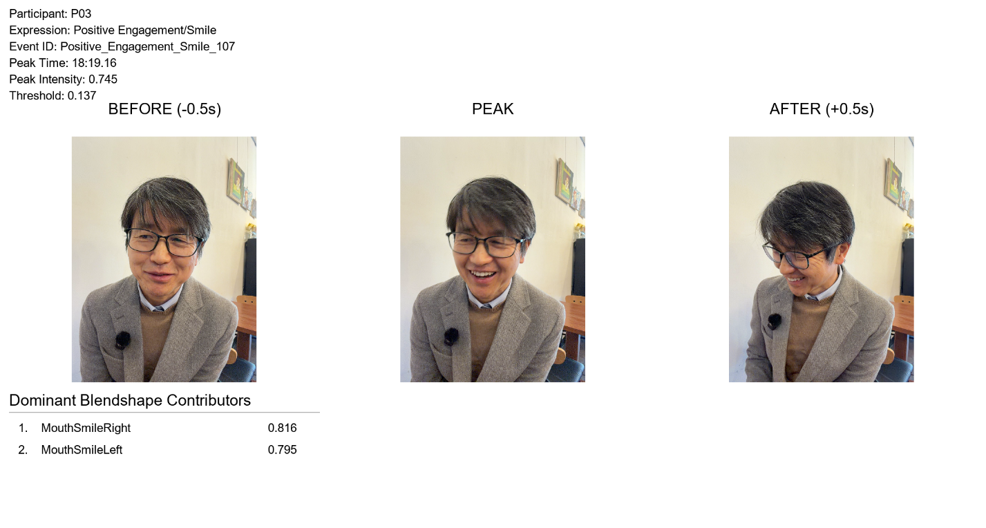

Figure 3. Synchronized video evidence panels (Before, Peak, After) for rapid qualitative event inspection
To improve visualization, spatiotemporal mapping and dynamic heatmap visualization was further developed. For every peak, a synchronized video frame is extracted for qualitative inspection and visual verification of our mathematical model. The newer system was upgraded to generate an additional panel representing the heatmap and also output videos with a length of 3 seconds to capture the entry, peak, and resolution phases of the expression.
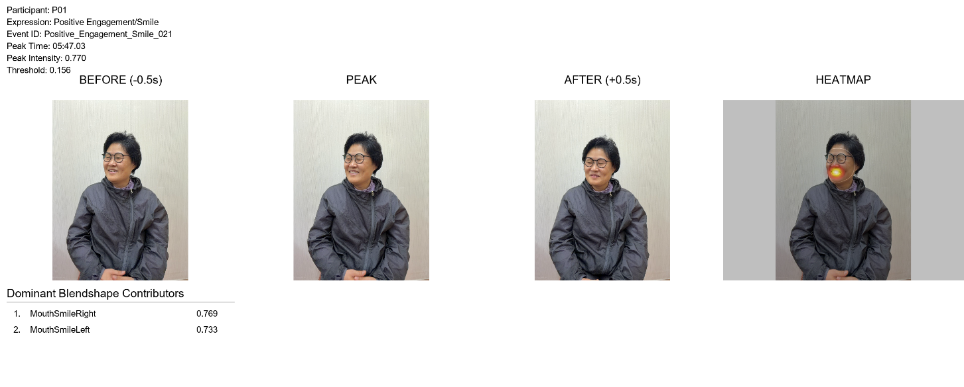

Figure 4. Enhanced spatiotemporal visualization panel displaying the continuous alpha-blended COLORMAP_HOT heatmap overlay and structural facial wireframe mesh.
Rather than using basic point plots, the system utilizes raw structural tracking coordinates from cvzone’s facemesh module to build a dynamic polygon array representing localized facial regions (eg, mouth_smile, mouth_frown). When a specific action unit crosses it’s calculated activation threshold, the polygon tracking coordinated associated with its underlying blendshape contributor are filled with their absolute scalar weights to build a localized 2D intensity map (Mask_{raw}).
Facial movements are distributed mechanically across connected muscle structures, so the raw mask is smoothed organically using a wide Gaussian Blue kernel (σ = 91, 91) to simulate skin tissue deformation, and then dynamically normalized to the full 8-bit dynamic spectrum to preserve visibility during subtle-microexpressions: Mask_{u8} = (Mask_{blurred} / max(Mask_{blurred})) * 255.
This normalized grayscale map is converted to a high-contrast biomechanical profile. In the initial design iteration shown in Figure 4, the system applied cv2.COLORMAP_HOT, where active muscle zones transition into intense incandescent red/yellow thermal cores over a localized transparent alpha boundary. To map passive baseline states more expressively, the system was updated to use cv2.COLORMAP_JET as shown in Figure 5, which demonstrates how active core colors smoothly dissipate outward into stable, cooling blue edges along resting muscle zones.
Finally, to eliminate flat background voids and maintain holistic anatomical context, a low-opacity structural facial mesh connecting standardized subset of 468 geometric landmark pairs is integrated beneath the gradient via continuous linear alpha blending (Final Layer = (alpha_{blend} * Heatmap) + ((1.0 - alpha_{blend}) * Base Frame_{Wireframe})), which scales the heatmap up to a maximum opacity of 75% over a base frame containing the original video tracking blended with the wireframe canvas at a fixed 25% opacity.

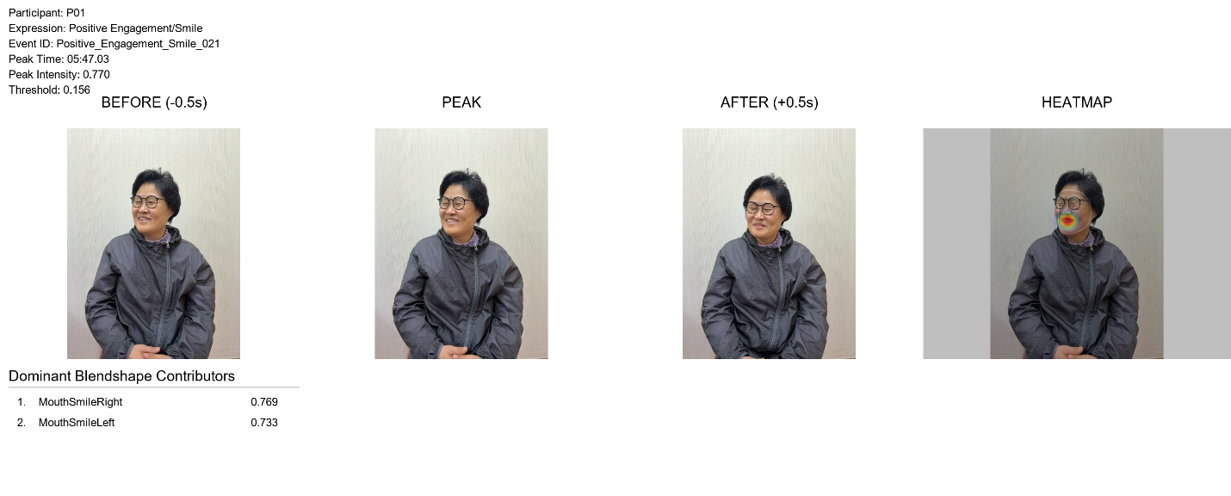

Figure 5. Visualization panel displaying the continuous alpha-blended JETColor heatmap overlay and structural facial wireframe mesh.
5. Conclusion
The developed pipeline provides an automated method for analyzing facial behavior frequency using ARKit blendshape signals and FACS-inspired expression synthesis. By combining smoothing, peak detection, and synchronized evidence visualization, the system enables scalable behavioral inspection cross multiple participant recordings while maintaining interpretable outputs for further analysis.

